SERVICE DOG YOGA
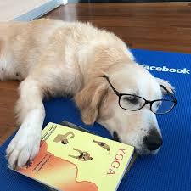
Learn the true meaning of Downward Dog at
Maureen Rae’s Yoga Studio, 5324 Dundas Street West, Etobicoke
With COPE Service Dogs (Canine Opportunity, People, Empowerment)
Sunday, April 28th, 2019
Two classes available at 11 am or 1 pm.
Join Maureen, Briar and Jane Boake for a fun and informative yoga class with COPE Service Dogs and hopefully some puppies. Maureen will teach at 11am and Briar at 1 pm. Before each class Jane Boake will demonstrate how these dogs can open cupboards, turn off lights and help us undress!
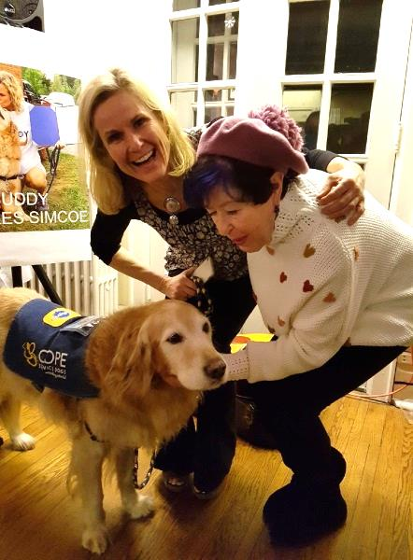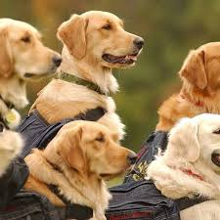
Jane Boake, Maureen Rae and Buddy COPE Service Dogs
Register on line www.mraesyogastudio.com or 416-716-7589.
Please register early as we anticipate this event will sell out.
It’s going to be doggone great!

